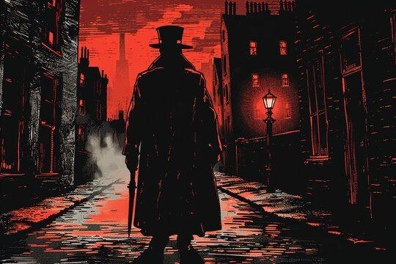
Jack the Ripper: The Anatomy of a Legend

Introduction
Few figures in criminal history have captured the public imagination quite like Jack the Ripper, the unidentified serial killer who terrorized London’s East End in 1888. The Ripper murders, though confined to a brief period of time and a small geographic area, have spawned more speculation, investigation, and cultural mythology than perhaps any other crime in modern history. The case represents not only a horrifying series of murders but also a fascinating intersection of Victorian society, media sensationalism, and the psychology of fear.
This article explores the enduring fascination with Jack the Ripper through three lenses:
- the historical context of the crimes,
- the evolution of the investigation, and
- the broader cultural significance that transformed an anonymous murderer into a symbol of modern urban terror.

The Historical Context: London’s Dark Underbelly
To understand the legend of Jack the Ripper, one must first grasp the social landscape of Victorian London. The East End, particularly the district of Whitechapel, was a microcosm of urban poverty, overcrowding, and moral decay. Streets teemed with beggars, prostitutes, and immigrants living in squalid conditions.
Key features of the East End in 1888 included:
- Overpopulation: Up to 900 people per acre in some districts.
- Extreme poverty: Many residents survived on casual labor or prostitution.
- Lack of sanitation: Open sewers and rampant disease.
- Moral hypocrisy: The respectable classes ignored the social conditions that produced vice.
In this environment, the Ripper’s victims—mostly destitute women engaged in prostitution—were tragically invisible. Their deaths only gained attention because of the unprecedented brutality and surgical precision of the killings, which shocked Victorian sensibilities and exposed the darkness beneath London’s polished veneer.

The Murders and the Investigation
Between August and November 1888, five canonical victims were murdered in Whitechapel. Each case shared elements of method and mutilation that suggested a single perpetrator.
Victim | Date of Murder | Location | Distinguishing Features
Mary Ann Nichols | 31 August 1888 | Buck’s Row | Throat cut, abdominal mutilation
Annie Chapman | 8 September 1888 | Hanbury Street | Organs removed with precision
Elizabeth Stride | 30 September 1888 | Berner Street | Throat cut, possibly interrupted
Catherine Eddowes | 30 September 1888 | Mitre Square | Facial disfigurement, kidney taken
Mary Jane Kelly | 9 November 1888 | Miller’s Court | Extensive mutilation, indoors
Despite the narrow time frame, the police failed to identify the killer. Theories proliferated, suggesting he might be:
- a surgeon or butcher with anatomical knowledge,
- a religious fanatic seeking to “cleanse” Whitechapel,
- or even a member of the aristocracy, as popular rumor had it.
The investigation was hampered by poor coordination between the Metropolitan Police and the City of London Police, and by a press hungry for headlines rather than truth. Letters allegedly written by “Jack the Ripper” to the police and media—such as the infamous “Dear Boss” letter—only deepened the mythos.

The Role of the Media and the Birth of Sensationalism
The murders coincided with the rise of the penny press, cheap newspapers that thrived on lurid stories. The Ripper case became the perfect spectacle:
- a mysterious killer,
- vulnerable female victims,
- incompetent police, and
- a terrified public.
Journalists blurred fact and fiction to boost sales, creating a media-made monster. Illustrations depicted the Ripper as a shadowy, top-hatted figure, symbolizing both evil and the hidden corruption of modernity.
The result was the birth of modern crime sensationalism, where journalism and entertainment merged. The archetypes first established by Ripper coverage—mysterious villain, urban horror, female victimhood—still shape true-crime narratives today.

Cultural Legacy and Psychological Significance
More than a century later, Jack the Ripper endures as both a historical enigma and a psychological mirror. His story is retold in books, films, and academic studies, each reflecting the fears of its era. Scholars analyze the Ripper case through the lenses of:
- Gender: The murders expose Victorian misogyny and systemic violence against women.
- Class: The victims’ poverty revealed the indifference of the elite.
- Media studies: The Ripper was the first criminal “celebrity” created by mass communication.
The fascination persists because the Ripper’s identity remains unknown. The mystery allows audiences to project their own anxieties—about power, sexuality, and morality—onto a faceless killer. The case thus transcends mere crime: it becomes a meditation on the human attraction to evil and the societal need to name it.

Conclusion
Jack the Ripper was not merely a murderer; he was a symbolic rupture in the Victorian psyche. His crimes illuminated the fractures within a society obsessed with progress yet blind to its own decay. The Ripper’s legend endures because it speaks to something timeless: humanity’s uneasy relationship with the darkness within itself.
In an era where true crime remains one of the most consumed media genres, the Ripper’s shadow reminds us that curiosity about evil often says more about us than about the killer himself.
References
https://www.nationalarchives.gov.uk/explore-the-collection/stories/hoax-letter-signed-by-jack-the-ripper/
https://www.jack-the-ripper.org/victims-of-jack-the-ripper.htm
www.fmhac.org/uploads/1/2/3/9/123913996/walter.pdf
www.jack-the-ripper.org/records-offices.htm

